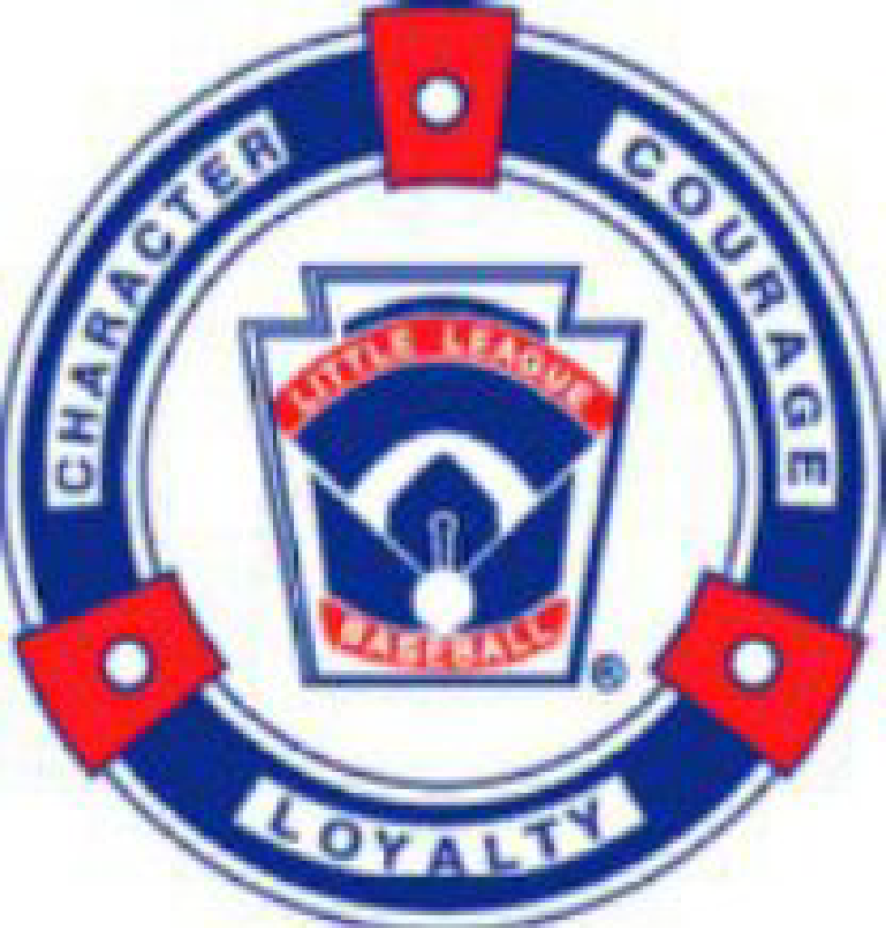

**High Plains Little League (HPLL)**

**01/27/2025 Board Meeting Agenda**

**Holtz House, Falcon, CO**

**01.27.1: Call to Order 6:03 pm**

In Attendance: Jared Holtz, April Holtz, Kevin Carpenter, Krista Brower, Gina Klimek, Jeff Klimek, Brett Reed, Jackie Reed, TJ Hartley, Ashley Carpenter, Doug Ziegler, Bobbie Lehman, Kristina Johnson. Only Jennifer Carlson not present.

**01.27.2: Meeting Minutes Sent via Email for approval**

* 12/16/24 meeting - 9 Votes to Approve - Majority considered approved
* 1/23/25 Special meeting - 9 Votes to Approve - Majority considered approved

**01.27.3: Resolution to Special Meeting Discussion**

* Board Positions Discussion

With 15 votes to approve and 3 non-responses, it is approved to remove Taryn Chubb, Tyler Chubb & Carey Jones from the Board.

Jim Van Horn is stepping down from his position as the High plains Treasurer. He sent an email resignation.

Replace Jim as Treasurer. Gina Klimek was motioned to be in that position. Jackie Reed 1st motion and Brett Reed seconded. all approved. No against.

Ashley offered to take on the All Stars stuff but not the actual tournaments stuff—will work together with TJ & Brett for All Stars.

TJ was nominated to be VP of Baseball-Jackie Reed Motioned, Ashley Carpenter 2nd the motion. All approved. No against.

All Star coordinator will be taken on by multiple positions and work together.

Kristina Johnson was nominated as Secretary (Gina Klimek’s current position)-Ashley Carpenter 1st, TJ Hartley 2nd—all approved. No against.

* Signer Changes on bank account—

Bobbie Lehman 1st & Jeff Klimek 2nd to put Gina Klimek on the bank account at ENT.

All approved. No against.

Bobbie Lehman 1st & April Holtz 2nd to put Ashley Carpenter as 3rd signer on the account at ENT. All approved no against.

Tyler Chubb Will be removed from the Farmers Bank Account. All approved. No against.

Jim Van Horn will be removed as he has resigned via email. All approved. No against.

* Committee concept for additional support

Have an audit & scholarship committee already. Would like to add: Golf Tournament-Doug was motioned to be the head—April & Kristina

All Stars Committee: Jeff, Krista, Kevin

All approved. No against for these 2 committees and the volunteers.

**01.27.4: Treasurer update(Gina):**

* Treasurer Status and update

Current balance $60,512.15 at Farmers State Bank

Current Balance $54,785.12 at ENT Credit Union

Registrations just came in. No expenses yet. Thus the higher balances right now.

Bobbie Lehman Motioned to close Farmers State Bank. TJ Hartley 2nd the motion. All approved. No against.

* Audit Committee-

Gina needs to be removed from the Audit committee because she is Treasurer now. Bobbie Lehman, Krista Brower & Kristina Johnson will be the new Audit Committee Members and Doug Ziegler to be there if need be.

* Current account status: Farmers and ENT
* Accountant discussion: Approved $3018 via electronic vote for Fiscal Year 2024 and 2023 taxes to be completed by accountant Becky Weese. 12 votes to approve electronically.
  + Need Minutes to note adding Becky Weese to our accounts as a “read only” access to both Farmers and ENT to manage our accounts.

Bobbie Lehman motioned 1st, Jeff Klimek 2nd to give her read only access.

All approved. No against.

State sales tax exemption after that. Then Raffle License. Get Current auditing up to date.

* Working Budget: Attempt 1 at approval of working budget for 2025

$11,500 add’l field rental because prices went up.

$26,500 spring sponsorship

Uniforms went down $11 from $31 – will save $11,000ish

Becky, Accountant, will help with Budget numbers too.

Want to touch on budget monthly and see where we are at.

Doug would like to know if we have a goal of savings—not at this time. Break even as a non-profit and being positive. We do have a surplus $50K do we want to invest? Maybe just half and see what ENT – has. Bobbie recommended not using ENT for investments. Kevin Clark is who Jared will connect with eventually. Jeff says lets track where we are through this year and see what our low point is and then at that point can invest less then that point. Comparing to CS & Academy, our prices are still lower. We have possible tax fines coming—unless they are waived. $1500 fall clinc sponsorship – we made some money because all shirts were covered.

Jeff Klimek motioned to approve working budget -Doug Ziegler 2nd  motion. Approved by all. No against.

* Amazon Business approval: $197 for account set up-

Jackie Reed motioned to approve, April Holtz 2nd motion. All approved no against.

If you are within your Budget, its ok to make purchases. Jared Holtz & Gina Klimek will have access to amazon account.

* Charter and Insurance for Little League: $4043.52 for 2025. Includes Challenger.

If you don’t use that same amount of teams, $ rolls over to the next year to use.

April – Venmo. Have multiple accounts—Golf Tournament, Concessions, Spirit Wear, sponsorships. Might have to set up saving accounts for Venmo accounts??

We will talk to bank and venmo and see how to set up.

Registration is all through the website. No venmo used for registration.

**01.27.5: Registration update(April/Krista/Kevin):**

* Current Numbers for registration 360 athletes

32 juniors cap at 36

60 majors have 3 coaches – cap at 5 teams

62 minors

53 rookies

72 tball

Coaches Need

3 tball 6 assistance 72 kids = 6 teams

2 rookies 5 assist

6 assistants for minors

2 head 4 assistant (Jeff said would take a majors team)

Softball—need 2 coaches

24 minors 4 wait

36 majors 1 wait (she will put on a team if need be)

23 juniors

Softball has some on wait lists. Last year 458 overall

* Hats ordered for 2025: Total $3,471.22—we spent almost $5000 last season but softball is not included yet.

They are coming in. Hats look the same as last year.

* Jersey Review and approval. No women fitted. Lot of options. Not quite as easy to design but will make it work for $11 per jersey. Saving $13K by using this company. Run on the bigger side.

TJ Hartley 1st motion to approve using the new company for jerseys. Brett 2nd. All approved no against.

* Scholarship update.

7 applied. All approved at 100%. 1 partial. All approved by the Scholarship committee.

10% of sponsorship money should go to scholarships. $2600 but had carryover – line item on Budget to be added and in quickbooks. Can offer for falls clinic.

* Spring Sponsorship update. $26,500 10 at 2k, 2 at $1500, 2 at $1000, 2 at $750

2 did not want to return from last year. We had new ones step up. All monies received were deposited into ENT. $1500 store credit from scheels on top of that.

Brochure thing – opening day—support sponsors and all the kids are in it.

Golf tourney flyer in there- more exposure.

Stovall-rock n roll off & springs remodel did not return

All Banners are still good and don’t have to have printed. Scheels is supplying their own.

* Fundraising notes: Dine In Nights. Raised $2300 on those nights.

Flyers to help raise – for bathrooms, etc. just put them on things. Capital funding.

Do an End of Season Thank you dinner for sponsors. Vibes Room – use catering for food with some drinks, cash bar and dinner. Silent auction at dinner.

Dinner we charge for – option for All Star.

Raffle – if you call it a Donation.

Wedding Venue in Black Forest.

We would like that in the brochure for opening night.

**01.27.6: Facilities for 2025**

* D49 Field Rentals: Woodmen Hills Approved, FMS Approved(limited to 4 days a week M T Th Sat), MRES Approved but limited (t-th, sat 12:30-4:30, sun after 10am). Still waiting on PLC for Softball Usage-initially said it was for SB not Baseball-waiting for a response. White would be split – with baseball then.

Balkin park – Turf $71/hr

* El Paso County Rentals: All Approved for FRP with all purpose for early practices.
* DBat for Tryouts and Early Spring Practices(Baseball)
* Woodmen Hills Elementary Gym for Softball Practices with all the grant stuff.

**01.27.7: Tryouts 2025(TJ and Brett)**

* February 22nd: 8-12 minors & SB and 6-9pm (majors 6-7 a-j 7-8 k-Z & Juniors 8-9). Makeup Monday 2/24 Time TBD.

Minors do a-j 8-9, k-z 9-10 1 hour each. Encourage parents to drop off only.

Lock up the batting cages.

SB 45 minutes. Minors 10-10:35 majors 10:35-11:20 Jrs. 11:20-12

* Discussion on time break down, volunteers needed, etc.

Neutral evaluators. 3 committed all day. Some kids from Juniors to help. Have some high schoolers to help facilitate.

Softball has evaluators.

Evaluation Sheets – Ashley & TJ. They will have big sheet for evaluators and a smaller version for coaches.

Evaluators-3ish, helping for fielding,etc. - need 6-8

18 or older need background checks. Connor will facilitating.

**01.27.8: Drafts 2025(TJ and Brett)**

* Feb 25th, 26th, 27th Times and Location break down discussion.
* 6 Drafts: Minors, Majors, Juniors on both Softball and Baseball

Tues 2/25 Majors BB 5:30 pm. Minors 6:45pm 25th at Rec Center

SB Wed 2/26 5:30 - 6:15 & 7, 45minutes each at Holtz’s

2/27 Juniors BB 5:30pm at Holtz’s

Special Events Food: $500 budget overall—all approved. No against

**01.27.9: Coaches Clinic(Brett and Jackie)**

* Vibes Conference Room: Saturday March 8th 9am-12pm
* Idea for Teeball/Rookies Coaches from 9-10, All Coaches from 10-11am, and breakouts for Minors, Majors, and Juniors from 11am-12pm.

New Coaches – most coaches have coached before

All board members should be at the Coaches clinic. Reeds are planning on Doing a powerpoint.

Softball – see notes

**01.27.10: Volunteer Status/Update(KristinaApril)**

* Coaches Status/numbers: recruitment conversation
* Background checks, etc. most are getting it done. must be done before evaluations.

75% done. Team Reach to join.

**01.27.11: Equipment(Jeff)**

* Jeff - Status to order for spring season- waiting on a few things from scheels.
* Amazon – few things to order.
* Plan for handing out equipment to coaches. We will get SB to Ashley.
* Vision for sign-out- do days of drafts to sign out

Sort out the baseballs.

**01.27.12: Safety(Jackie)**

* Safety Plan Status-april says amazing. A lot of cleaning up and doing a complete overhaul on it. Site maps. PLC answers. QR for weatherbug. Insurance claim information….may need updating.

Asking UC Health to donate safety kits. 1st aid kits…what you need to be in there:

Insta packs-2, extra in connex & concession stand. 40 first aid kits is what we need.

Need to add a safety line on Budget – Ashley Carpenter motioned, 2nd Gina Klimek-all approved. No against.

Each field needs a binders & safety kit

Any safety items used need to be replenished.

* Binder Plan for distribution to coaches at Tryouts. And T-ball & Rookies pick up at Holtz’s
* First Aid Kit plan/idea/budget—see above

**01.27.13:** **Scheduling/Umpires(Bobbi/Doug)**

* Status on Scheduling communication

Bobbie – draft schedule for all divisions. With plc and w/out. Working practice schedules with or without plc. D49s schools-graduations, memorial weekend, no Sundays used. 13-14 games scheduled. 6-8 makeups. CS interleague for juniors, 6 interleague games for majors on our FRP. Academy – will work with our schedule.

Trilakes – Bobbi is reaching out to them – schedules sent. Academy is only one who answered.

Ashley-trilakes SB, they wanted to be apart of it but waited to the last minute.

Head coaches on schedules for cancellations.

Championships are in the schedule. Week – after Memorial weekend.

Vibes- Juniors play on opening night

* Umpire plan/status - Contacts made—Rocky Mt./John all in to help. Pres Bob, he has pricing. Talk with Umpire Dick…how to qualify umps. Majors having 2 umpires last year cost $150 for 2, $85 for 1….we will have to make a decision, once get prices. BB—were leaving bases early, so it was requested for the 2nd ump. Interleague for some of the games. Possible idea of each team brings an umpire.

Age requirement for umpires?? Jared will find out.

**01.27.14: Open Discussion**

* **Important Date Schedule: Opening Day, Pictures, Uniform Handout**

4/19 at 9:30 opening day. 2 junior games at Vibes stadium. No concessions, sunbelt rentals….outside.

4/5 pictures/uniforms. Bennett Ranch $500-NO—so we called foundation Lutheran church. Conference Room at Vibes 8:30am starting.

Swirly cow registration date – in person next week

* Emails Change update—Doug & John working on this.

Google form to sign for safety plan ?

* Next Board Meeting 2/17 - Holtz House 6 pm
* Open Discussion

2/3 zoom meeting for Daniels Fund with Kevin & Jared

Meeting adjourned at 8:57pm

SOFTBALL:

Ashley’s talking topics

Woodmen Hills Elementary Gymnasium Schedule

3/18 5:30pm-7:30pm

3/20 5:30pm-7:30pm

3/21 5:00pm-9:00pm

3/25 5:30pm-7:30pm

3/27 5:30pm-7:30pm

3/28 5:00pm-9:00pm

4/1 5:30pm-7:30pm

4/3 5:30pm-7:30pm

4/4 5:00pm-9:00pm

4/8 5:30pm-7:30pm

4/10 5:30pm-7:30pm

4/11 5:00pm-9:00pm

2 minors hopeful for 3-need two head coaches (4 waitlisted)

3 majors hopeful 4-have coach, need athletes (1 waitlisted)

2 juniors full

We would need to rent an additional time slot if we pull a third minors and a third majors. We have the space/hours for 8 teams now.

8 hrs a week X 4 weeks=32 hours requested  
32 hrs X $20 hr=$640  
VS  
Dbats would be 7hrs a week X 4 weeks = 28 hrs requested  
28 X $24 hr=$672   
  
So yes I am only saving $32 but our teams are getting a two hours practice a week instead of only one hour, and in a bigger area.

My equipment costs came out $223.67 over my $5,000 grant funds. ($5223.67) Jeff approved the overage to come out of his equipment budget at a prior board meeting, I did keep him in the loop when the overage was different so he approved 12/24/2024.